CGG ID : MAR INS MNL 019E

USER GUIDE:
STANDALONE DEVICE for SRD device programming




Visas / Document Control

Versions / Change Record
Date | Auteur / Author | Version | Modifications / Change Reference
2015/29/01 | Anthony HUE | - | Creation
2015/12/07 | Anthony HUE | A | Description and using of RFID Antenna
Revue / Reviewers
Nom / Name | Fonction / Function | Date | VISA
NO | Project Manager | 2015/29/01 | NO
NO | Project Manager | 09/12/2015 | NO
François Le Goff | Project Manager | 09/01/2016 | FLG

Table of contents

1 Visas / Document Control 2
2 Table of contents 2
3 PRODUCT OVERVIEW 2
4 OPERATING MODES 6
5 GETTING STARTED with STANDALONE DEVICE 10
6 TROUBLESHOOTING STAND ALONE DEVICE 10
7 CAUTIONS 12

PRODUCT OVERVIEW

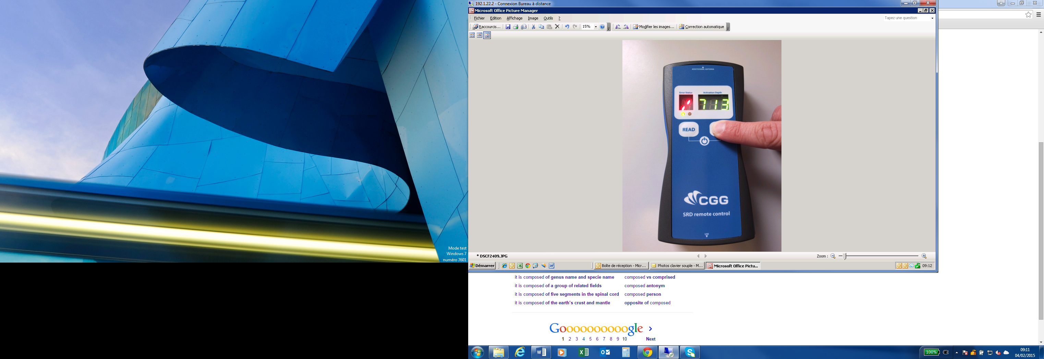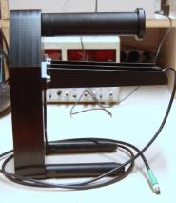

The standalone device and its deported antenna are used to communicate with the SRD programmable activation cone (P-Cone), to:
- Verify configuration (activation depth, filter, battery level and another status which are indicate in this document)
- Programming with specific configuration (activation depth and low pass filter value).

This device operates in two operating modes:
- standalone
- connected
In standalone mode, the device can be used with a remote wire RFID antenna depending on the working situation.

The standalone device is composed of:
- One electronic card
- One battery (lithium-ion)
- One alphanumeric display (1 red digit 8 segments) and one three green digits display (7 segments)
- One RFID antenna
- One hand held enclosure
- One membrane keypad
- One USB Female plug for connecting computer or tablet
- One Serial female plug for connecting remote RFID antenna

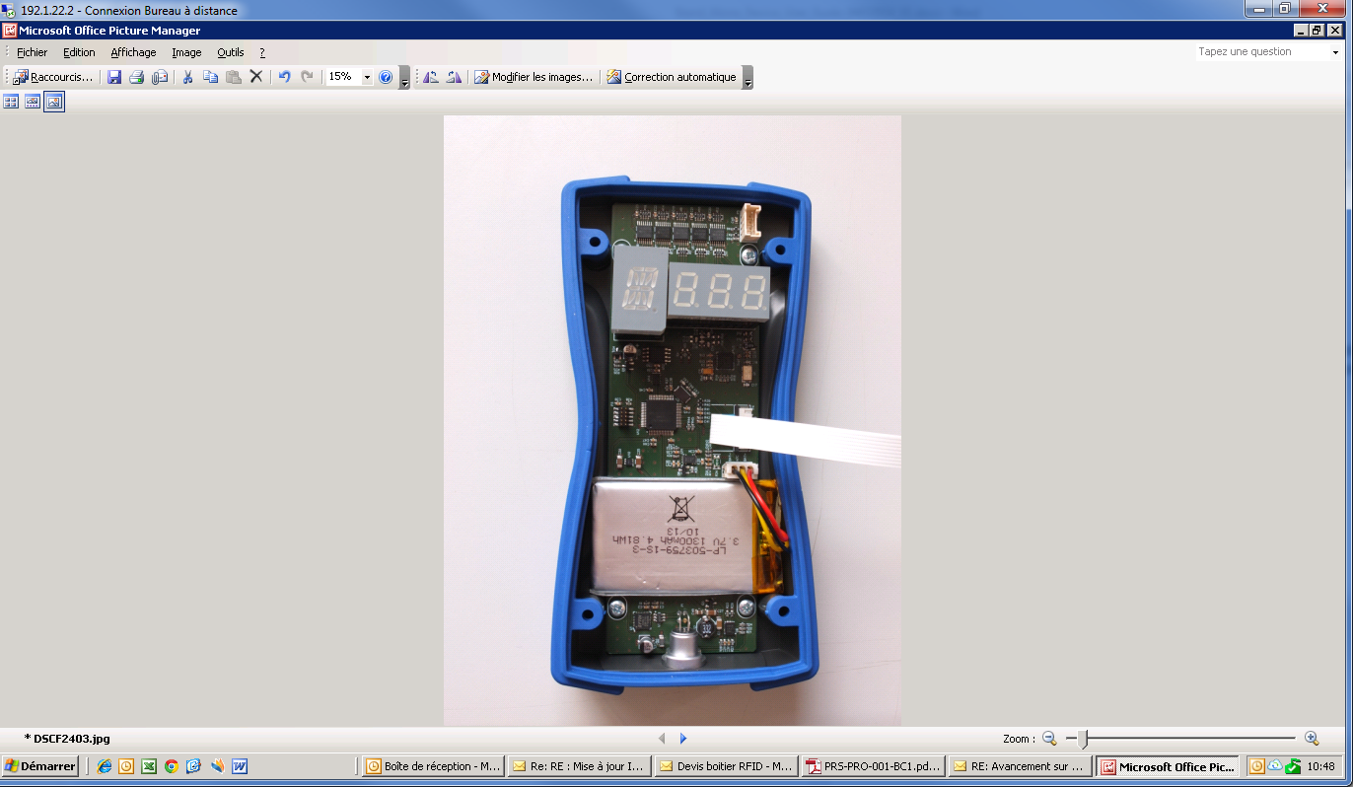
Numeric display
Gasket
RFIF Antenna
Located under the electronic board
Alphanumeric display
Electronic Card
USB Female Plug
Battery
Stand Alone device Inside View

Errors values for SRD device or Standalone device
Activation depth values memorized or read
Membrane keyboard
Serial female plug for connecting remote RFID antenna (located on front side)
Standalone device Top View

View of the RFID antenna with positioning mechanical tool:

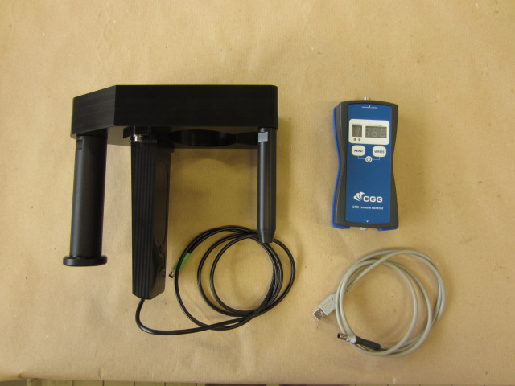
Handle of the positioning mechanical tool
Mechanical piece for positioning the RFID Antenna
Serial cable for connecting Stand Alone Device
Emitting area of the RFID Antenna
Mechanical Tool for the RFID Antenna positioning

View of the RFID antenna positioned on a SRD:

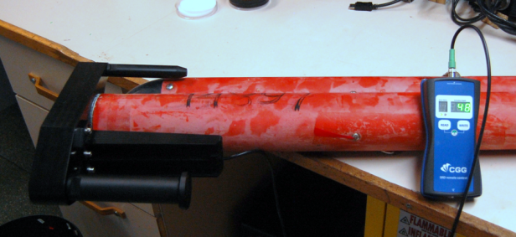
Positioning Mechanical Tool
RFID Antenna
Stand Alone Device
RFID Antenna positioning on SRD

Remark: the positioning mechanical tool is specially designed to fit on the SRD activation cone, therefore there is only one position to insert the tool (the picture above shows the right position).

OPERATING MODES

This equipment can operate in two modes:

- Connected mode (USB connection)

The device is connected to a tablet (or computer) by using USB connection.
The corresponding software (config SRD V1.00) must be installed on tablet (or computer) to control the electronic device (tab“Standalone Box”).
See manual PR 000 232_A_UTI/ MAR INS MNL 020E for configuration and use of the software.

Standalone Box page:
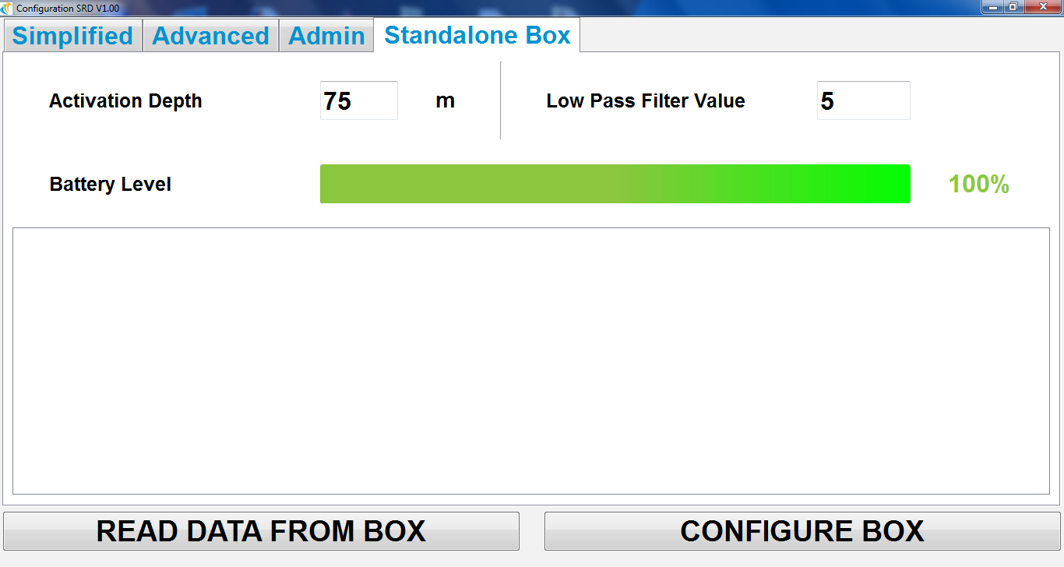

This IHM allows to:
- CONFIGURE BOX
Click on the configure button to write parameters in the standalone device:
- Activation depth (in meter)
- Low pass filter value: necessary number of successive depth measure upper or equal to activation depth to activate the SQUIB.

- READ DATA FROM BOX
Click on the read button to retrieve information stored in the standalone device memory (information coming from the SRD P-Cones):

- Date
- Time
- type of operation
- Firmware version
- Error status
- Activation depth configured
- Low pass filter value
- Serial number of the P-cone
- Battery Level:
  - A progress bar shows the battery level, in red if < 10 % in green if > 10%
  - The battery level is given in % on the right

- Supercapacitor Level
- Threshold battery applied
- Activation Depth measured
- Max measured Depth
- Serial number of the SRD.

Remark 1: data (written or read) are stored in csv format on a .txt file (by default the filename is called LogBox). The Default path is the same than Config_SRDV1.00.EXE. The data are displayed on Standalone Box page (see below) and listed for each operation on P-cone (data written or read).
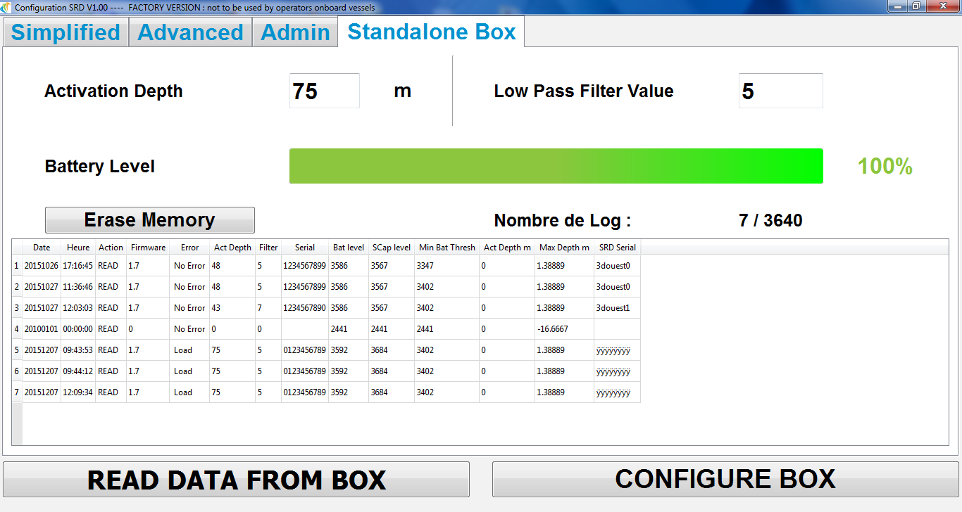

Remark 2:
When you plug the device on tablet (or computer) and open the "StandaloneBox" page, the date and time of the electronic device is updated.

- Standalone mode

The standalone device is powered by its internal battery and by default is in a low mode power. A simple pressure on READ or WRITE button wake up the device.

The standalone device embeds an antenna on the back of the box, so the device can be located directly on the top of the SRD body, in front of the communication antenna of the electronic board.
This embedded antenna may have a weak communication (and is more difficult to locate properly). We recommend the use of deported antenna that have better RFID sensitivity and offer better positioning on the SRD body.

The button “READ” records a set of data from the P-cone memory in standalone device memory. After a read operation, the results (error code if any and activation depth) are displayed during 3 seconds.

The button “WRITE” write data (activation depth and low pass filter) inside the P-cone memory.
The result of a WRITE operation is displayed during 3 seconds.

Red LED
Green LED
Read button
Write button

The red and green LEDs are used to indicate the result of operation. The green one indicates a success and the red one indicates an error (see Troubleshooting chapter).

To get RFID communication, whatever the READ or WRITE operation, you have to maintain a pressure on button, waiting for display of configured activation depth with no errors displayed.

So long as the communication is not established, an error is detected and displayed (see Troubleshooting chapter).

Simultaneous pressure on READ and WRITE buttons displays alternatively the activation depth configured and then the battery level of standalone device.

GETTING STARTED with STANDALONE DEVICE

- Plug the USB cable between Standalone device and computer.
- Open ConfigV1.00 software
- Click on the standalone box tab
- Configured the activation depth and the filter value
- Click on Configured Box to send data in standalone device memory.
- Unplug the USB cable
- Verify the activation depth configured pushing the READ and WRITE buttons simultaneous
- Connect the deported RFID antenna if necessary (depends on your working situation)
- To get a successful operation (read or write) you need to be close to the SRD P-Cone. Both RFID antennas (standalone device and SRD P-cone) must be in the same axis and a distance lower than 5 mm when using the internal RFID antenna of the standalone device.
- Press and maintain the button WRITE, waiting for display of configured activation depth with no errors displayed. Do the same action if you want to READ data from the P-cone device for check.
- By using the ConfigV1.00 software you can download the data and check the different parameters (saw in a previous chapter: operating modes )

TROUBLESHOOTING STAND ALONE DEVICE

- Error from Standalone device

The standalone device can detect and display the following error codes:
WErr: error detected for the data writing operation inside the P-cone electronic (the data written and the check data are different).
ELog: error detected for the log operation (write or read), no memory space available for the data storage.
PErr: The configured depth parameters in the standalone device are false.
DErr: The configured time and date inside the standalone device are false. To fix it, connect the standalone device to a computer and open the ConfigV1.0 software (Standalone box tab). The date and time will be updated.
RErr: error detected for communication RFID. Likely the antenna is not in correct position.
BErr: error detected for battery level (battery not connected or error on temperature sensor located inside the battery.

The list of errors from standalone device is displayed on the rear of the device:

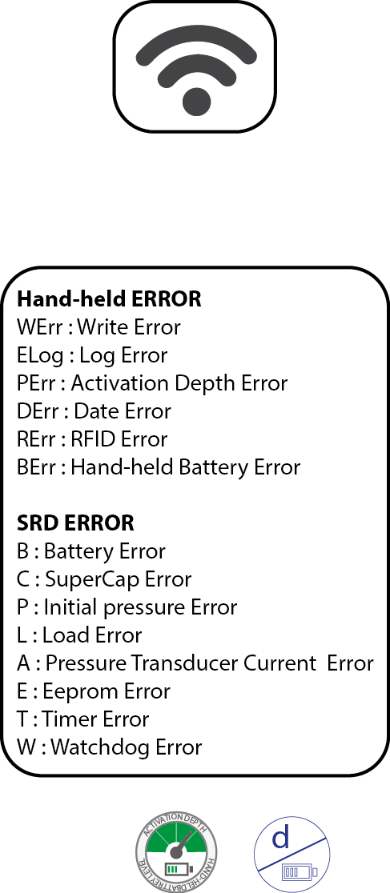

- Error from P-cone device

The standalone device can also detect the following error from SRD P-cones:

B: Battery error
C: SuperCap error
P: initial Pressure error
L: Load error
A: pressure sensor current error
E: EEPROM error
T: Timer error
W: Watchdog error

The list of errors from SRD P-Cone is displayed on the rear of the device:

Remark: This list is defined by priority (from the most important error to the least important error) because all errors cannot be displayed in the same time.

CAUTIONS

- The standalone device is protected against water jets (IP65).

- If the standalone device doesn’t wake up when you touch button, connect it on computer and wait for the battery reload

