

USER GUIDE
SRD configuration HMI
version 1.00

CGG ID : MAR INS MNL 020E



Visas / Document Control
Versions / Change Record
Date | Auteur / Author | Version | Modifications / Change Reference
31/07/2014 | Anthony HUE | - | Creation
04/12/2015 | Anthony HUE | A | Update version 1.0 / Installation (Drivers, new interface), addition of a troubleshooting part
Revue / Reviewers
Nom / Name | Fonction / Function | Date | VISA
NO | Project Manager | 31/07/2014 | NO
NO | Project Manager | 07/12/2015 | NO
François Le Goff | Project Manager | 07/01/2016 | FLG

Table of contents

1
1
1. Visas / Document Control 2
2. Table of contents 2
3. PRODUCT OVERVIEW 3
1.1 Introduction 3
1.2 Overview 3
4 OPERATING HMI 5
4.1 ADMIN MODE 5
4.2 SIMPLIFIED MODE 7
4.3 ADVANCED MODE 11
4.4 LOG FILE 12
5 Trouble shooting 14
5.1 Truncated word 14

PRODUCT OVERVIEW

Introduction
This document is a user guide to configure SRD programmable activation cone (P-cone) using the tablet and HMI.
This HMI allows to configure SRD P-Cone and also a standalone box. To use it, you can read the MAR INS MNL 019E user guide.

Overview
This HMI (Software version 1.00) allows configuring SRD programmable activation cone by RFID antenna (operating with M24LR024E RFID). For RFID communication success (in simplified and advanced mode), the RFID antenna must be the near to SRD cone (< 1 cm).

Three modes are available:
- Simplified
- Advanced
- Admin
Both of them should be used by an appropriate person:

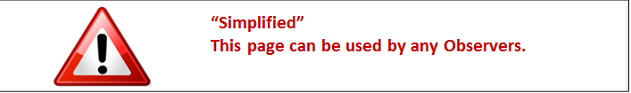

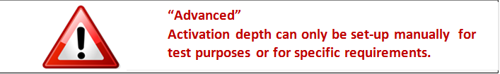

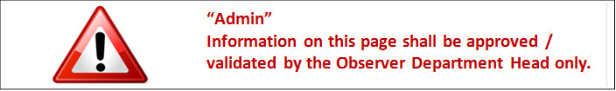

- PC system configuration

OS : Windows XP and over (Windows 10 include)
Display resolution: 1024X768 optimized

- Getting started

Plug-in the RFID antenna on USB port before using the HMI.
Past the ConfigSRD_v1.00 directory on your PC:

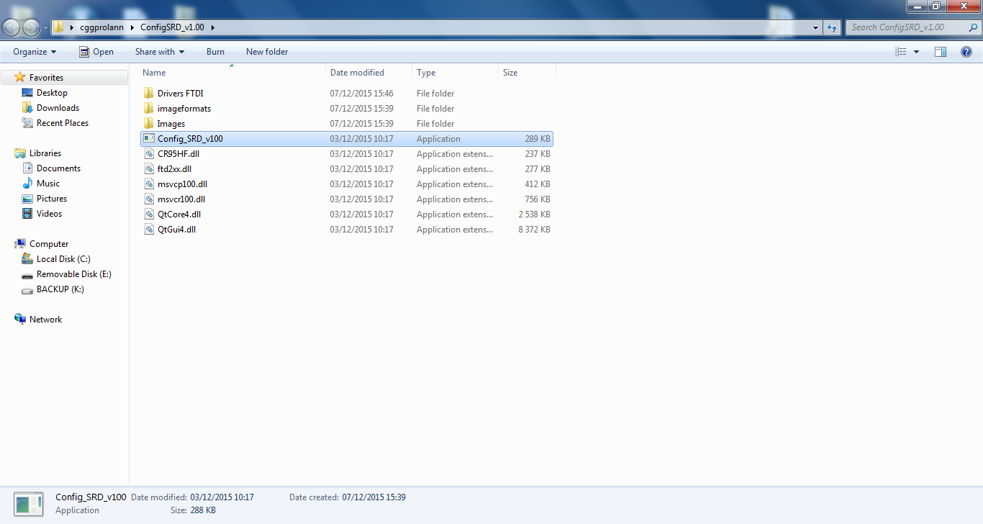

Now the application Config_SRD_v1.00 is ready to be launched :

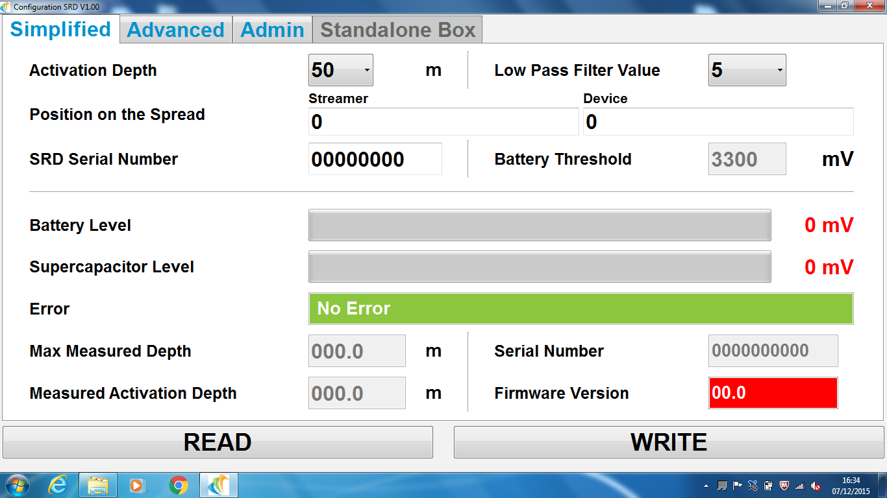

OPERATING HMI

ADMIN MODE
Here below, the admin mode page:

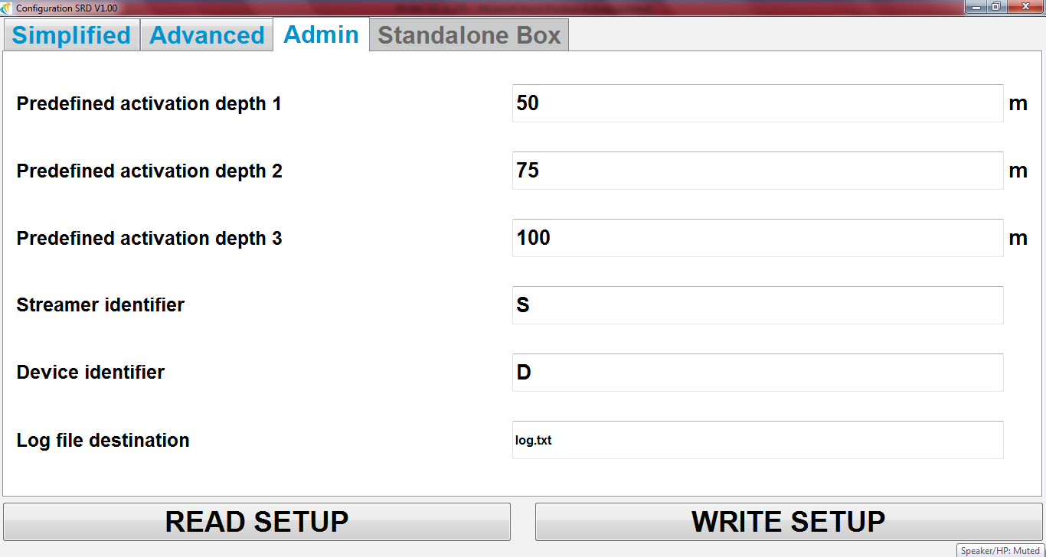

For easy use with tablet PC, the numeric values are set with the virtual keyboard. It display when clicking inside the parameters fields:

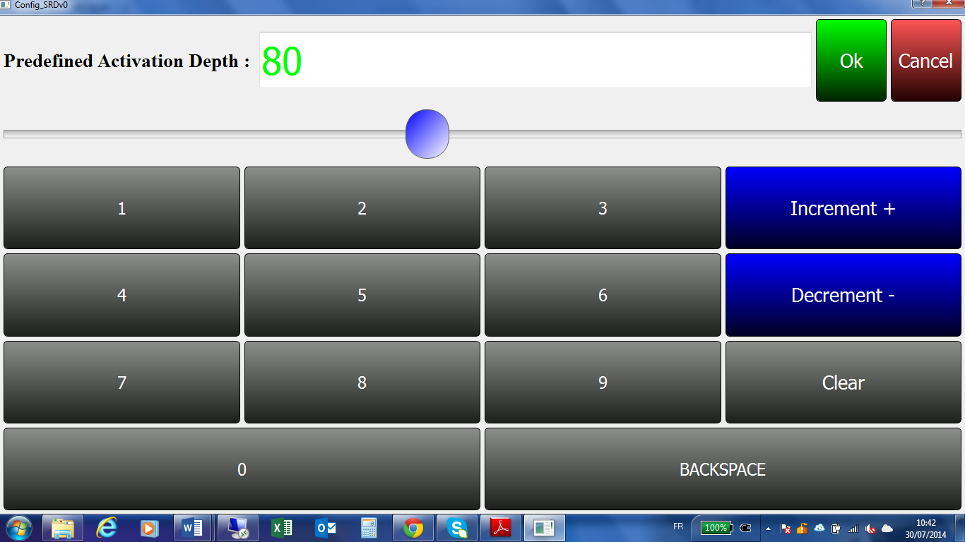

Parameters function:

Predefined Activation depth 1, 2 and 3:
Those fields are used to configure three activation depths in meters.
By default those parameters are 50, 75 and 100 m.

The values configured in Admin tab are available in the drop-down menu on the Simplified tab:
Those values fill the form “Activation Depth” in Simplified mode

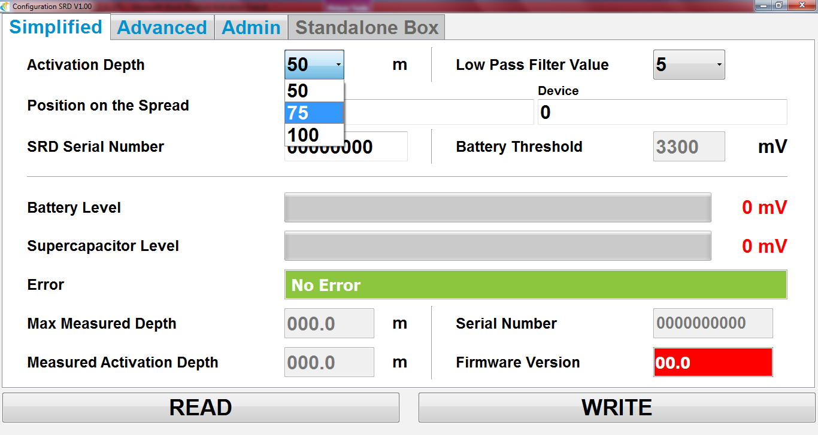

The data are displayed in the ordered on Admin tab (depth 1, depth 2, and depth 3)

Streamer identifier :
Streamer identifier is the streamer ID on which the SRD cone is installed. (S1, S2…, Sn)
One letter to recognize data: By default S for streamer
A letter (one character) is required

Device identifier :
Device identifier is the position of SRD on the streamer (D1, D2,…, Dn).
One letter to recognize data: By default D for Device.
A letter (one character) is required.

Log file destination :
Name of the file where data read to and from the P-Cones will be recorded. The file is co-located in the application directory.

WRITE SETUP button:
After any modification, the new configuration shall be written in the application by clicking on the Write Setu button.
A message appears to indicate the operation state: successful or failure.

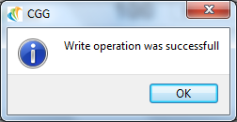

READ SETUP button:
A click on this button will restore parameters as they have been saved the last time.
A message appears to indicate the operation state: successful or failure.

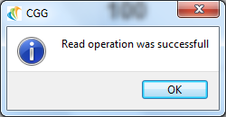

SIMPLIFIED MODE

The USB antenna shall be connected to the computer before launching the software.

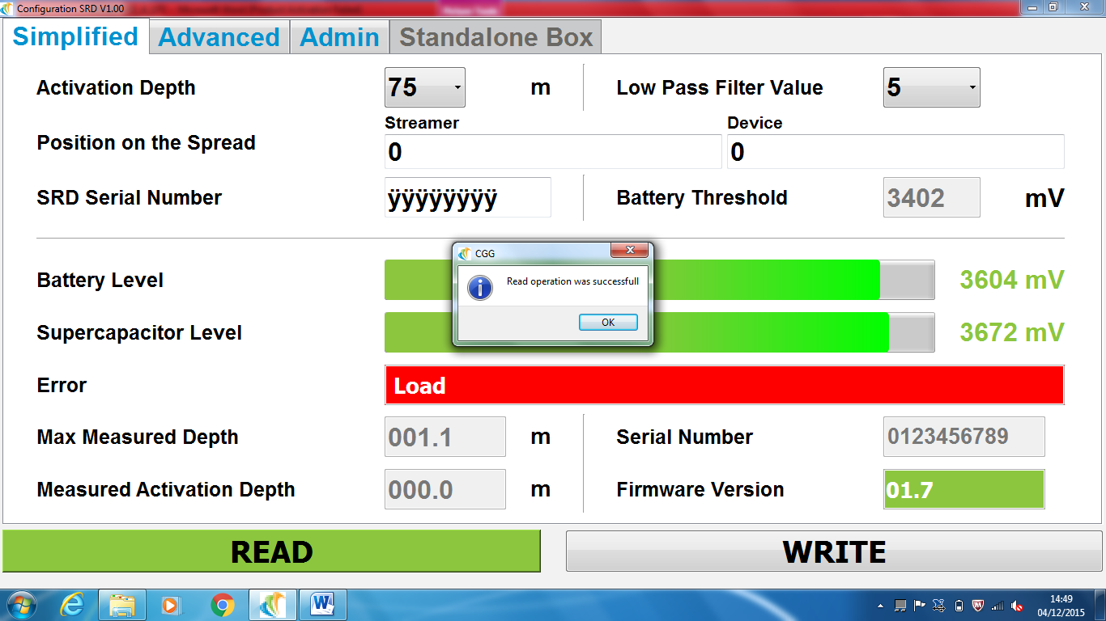

The RFID antenna must be positioned near to the SRD P-Cone, in front of the electronic board antenna (< 1 cm):

Clicking on the READ button retrieves the following information from the P-Cone:
- Activation depth (in meter)
- Low pass filter value: necessary number of successive depth measure upper or equal to activation depth to activate the SQUIB.
- Position on the Spread (Streamer and Device) shall be 0 (Not memorized in SRD cone EEPROM)
- SRD serial Number (by default shall be ÿÿÿÿÿÿÿÿ) (SRD Body S/N)
- Battery Threshold
- Battery Level
- Supercapacitor Level
- List of error (for monitoring physical parameters of SRD cone):
- Max measured Depth (in meter). When SRD is activated the “max measure depth” is equal to “measure activation depth”.
- Measured Activation Depth (in meter)
- Serial number of the SRD cone PCB (by default shall be: 0123456789)
- Firmware version of the PCB.

For each reading and writing, a message indicates the successful or failure of the operation:

Message for successful reading:

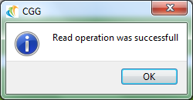

Message for RFID communication error:

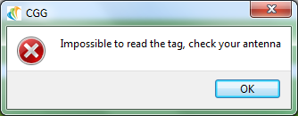

This error is likely due to miss-location of the antenna or miss-function of the antenna:
- Check the distance between the active part of the antenna and the body of the SRD
- If using free-hand antenna, move slightly forward/backward or turn slightly the antenna, try to read again
- If still doesn’t work: Close the ConfigSRD_V1.00 software, unplug the USB antenna, and plug it again after verification; launch the software and try again.

List of error of SRD P-Cone (monitoring of physical parameters):

The SRD P-Cone saves monitoring data in internal EEPROM during initialization and running phases; they are used to display error message in the HMI application. If there is any error, the SRD P-Cones LED blink with quick flashing.

The data stored are:
- level of battery and Supercap at last initialization
- the threshold for battery error
- load value
- pressure in initialization phase
- sensor current
- phase timer with watchdog
- EEPROM state.

For each error, the field error switches on red colour. in case of multiple errors, they are all displayed in error field:

Example with a “load” error:

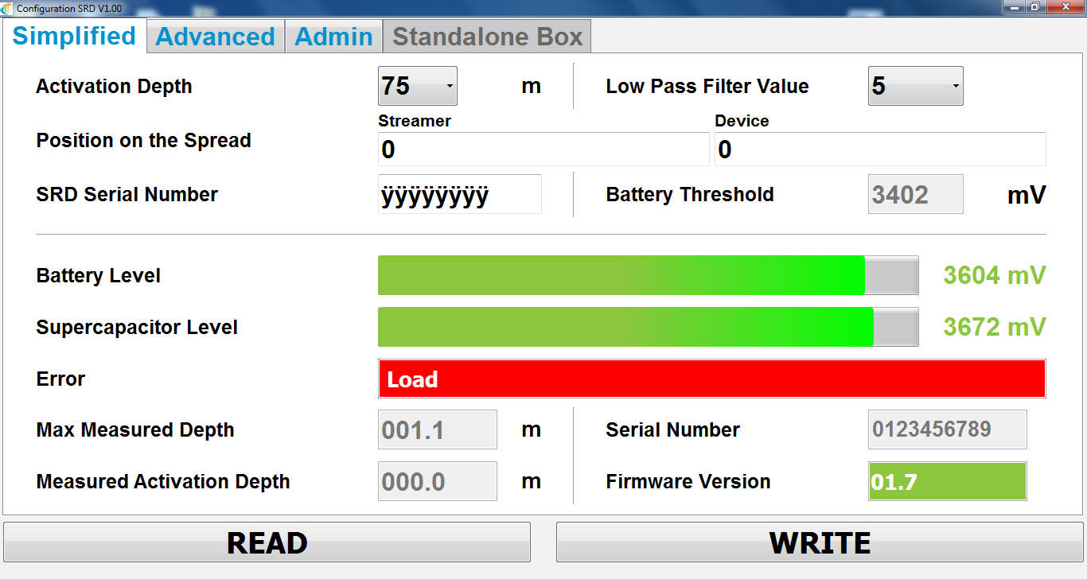

The error list and explanations appear by clicking into the error field:

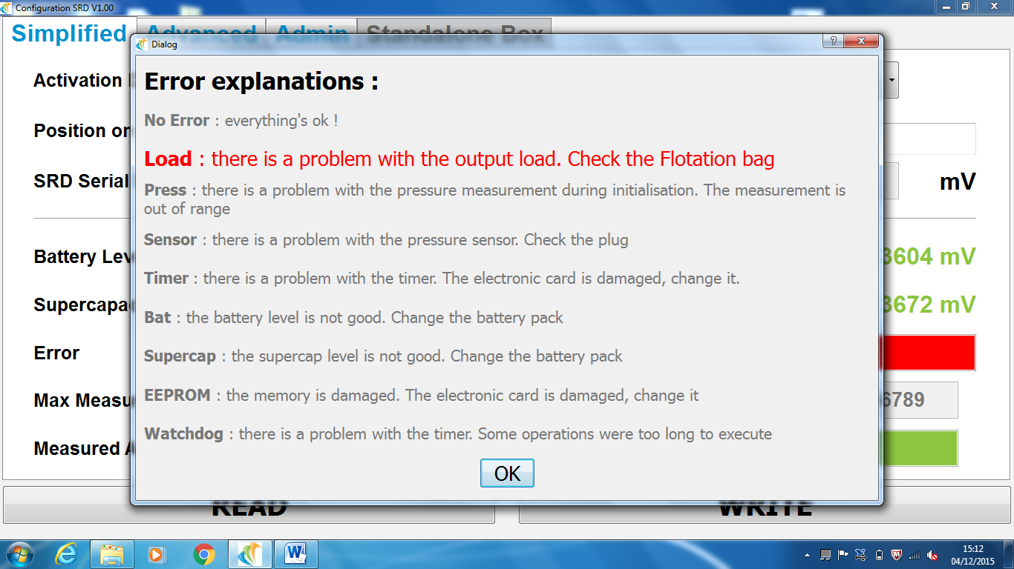

The error list and explanations for “no error”:

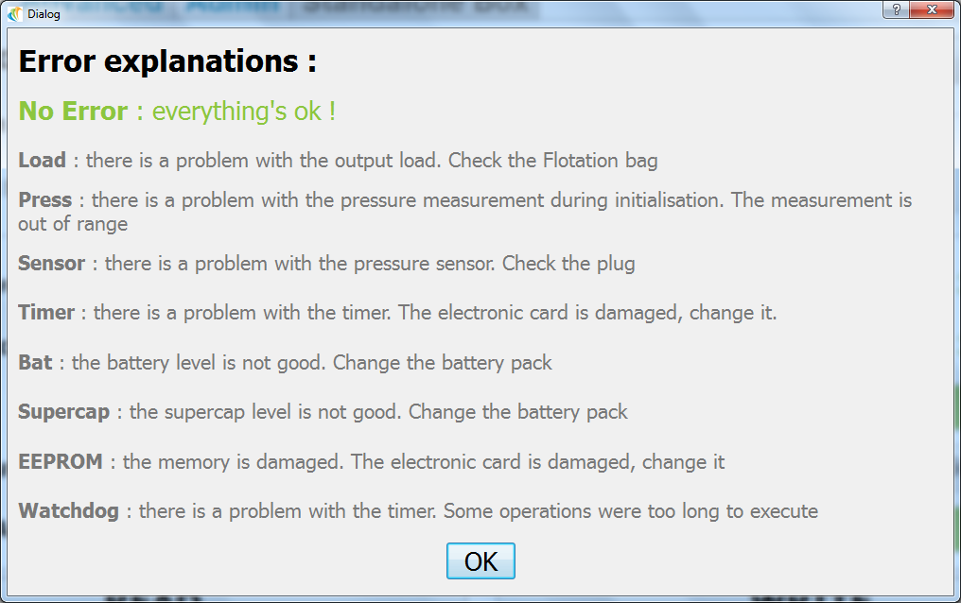

Note: “Check the Floatation bag” means: Check the Floatation Bag Assembly

Here below, the simplified mode page with another error field in red for “SuperCap error” and then the error list windows which indicates and defined the SuperCap error:

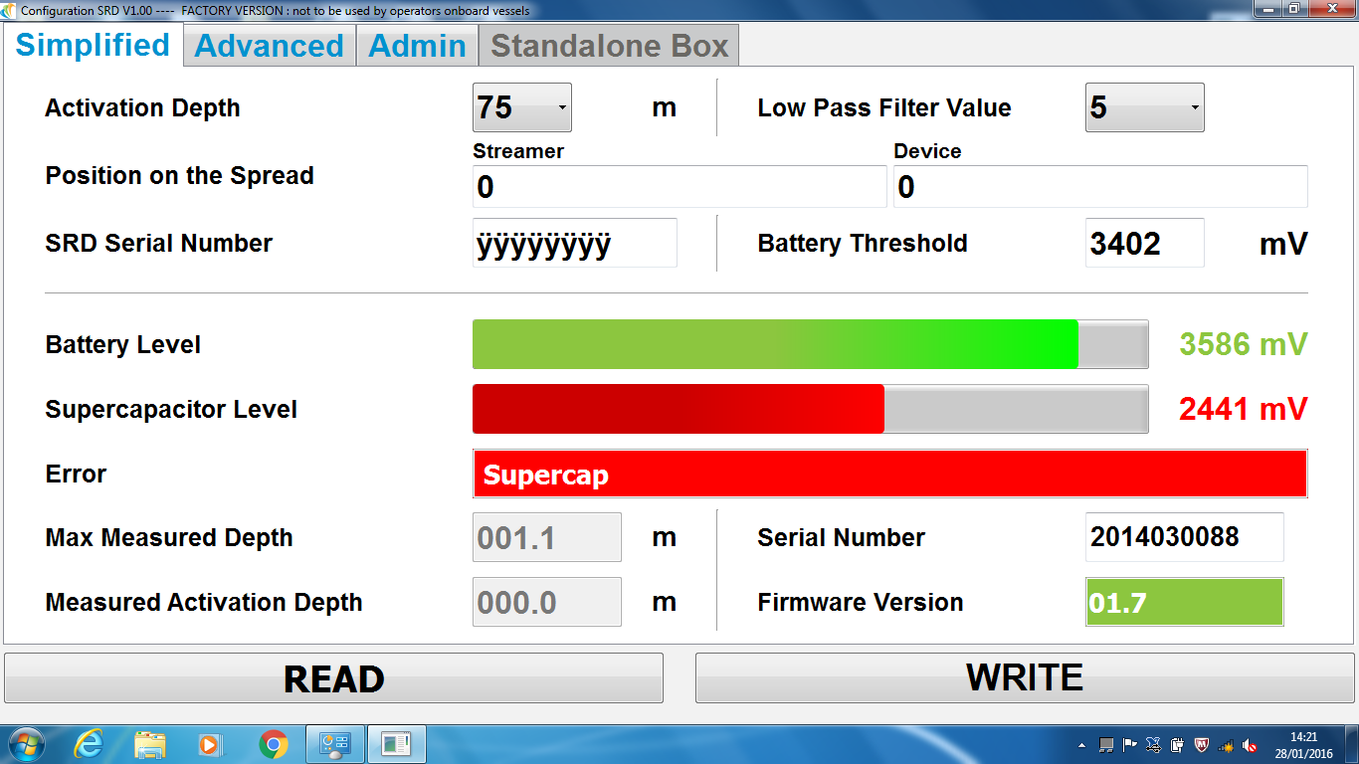

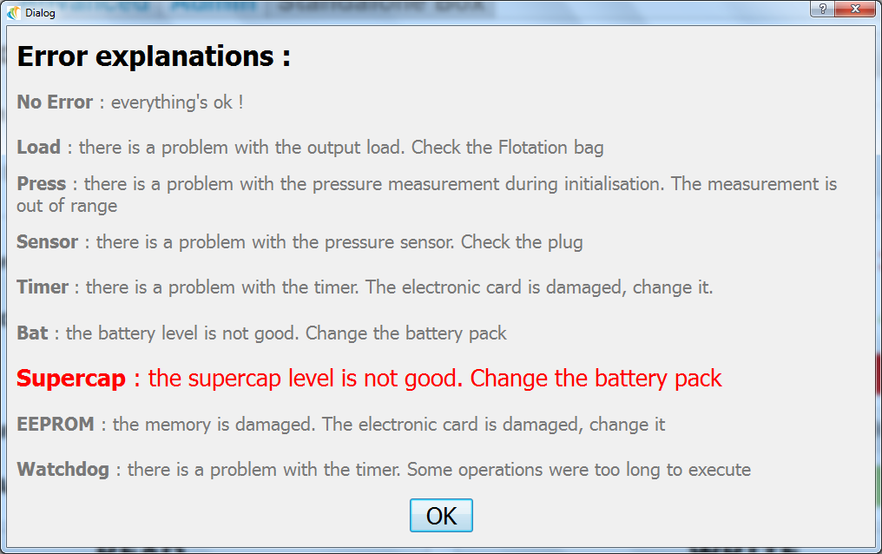

ADVANCED MODE

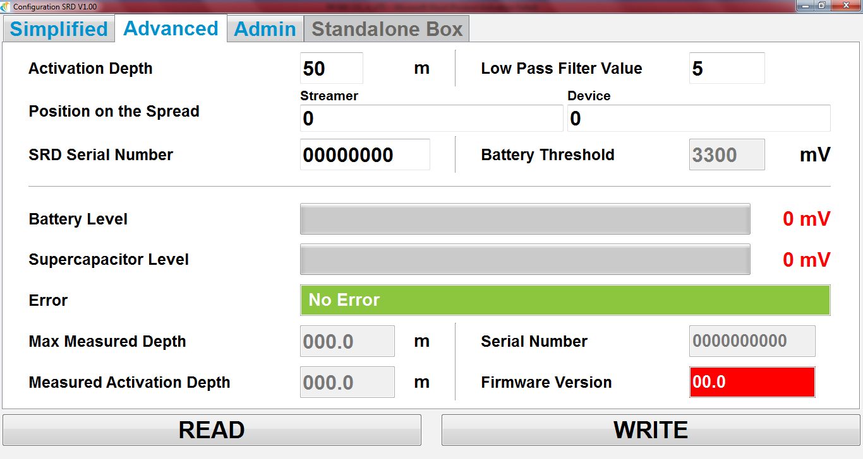

The Advanced mode provide the same configuration field than Simplified mode, but offer the possibility to set any value for activation depth and Low pass filter.
Those two fields can be filled using the keyboard instead of a drop-down list.

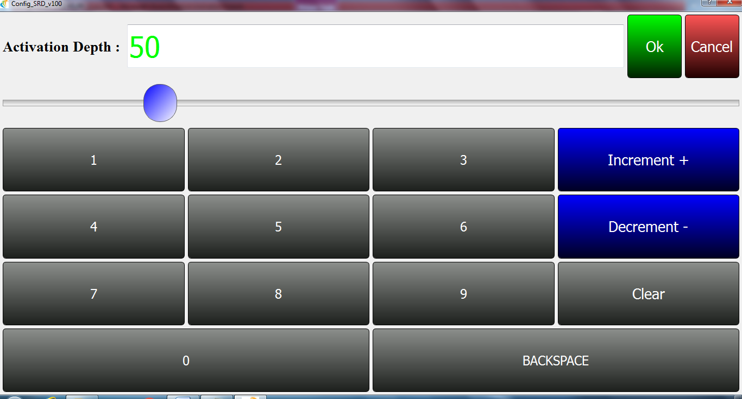

Remark: those parameters are not saved on simplified mode.

LOG FILE

If Log file destination is filled in Admin mode, data read or write in the SRD P-Cone are stored in csv format on a .txt file. Default path is the same than Config_SRDV1.00.EXE

Here below, the content of Config_SRDV1.00 folder with log file:

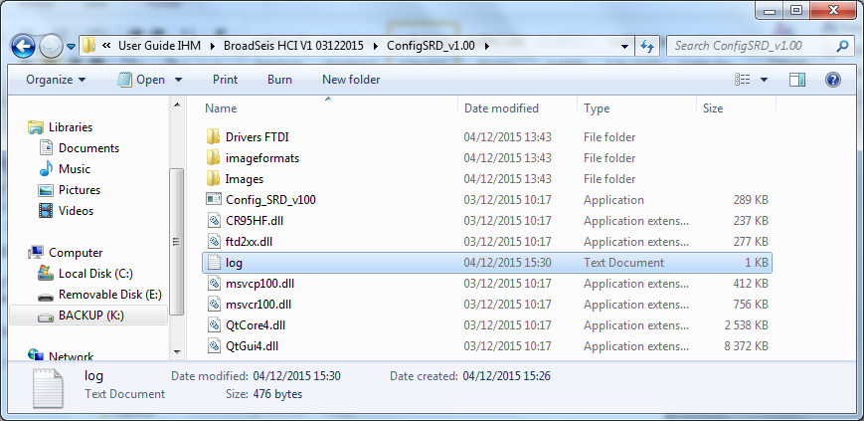

Note: txt.log file can be saved and moved to other location.

Content of the data log data file:

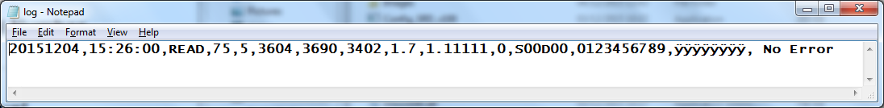

Respectively, the log file display:
- The date: 20140728
- The time: 15:26:00
- The type of operation: READ
- The activation depth: 75 m
- The low pass filter: 5
- The Battery Level: 3604 mV
- The Supercapacitor Level: 3690 mV
- The threshold battery: 3402 mV
- Firmware version of the PCB: 1.7
- The Max measured Depth (in meter): 1,11111 m
- The streamer identifier: 00
- The device identifier: 00
- Serial number of the Electronic Card : 0123456789
- Serial Number of the SRD Body (if specified or default Id ÿÿÿÿÿÿÿÿ)
- The list of errors detected if any

In case of activation, the electronic stop running after it activates the floatation bag. As a consequence, the field “Max measured Depth” is not updated after the activation: it doesn’t provide any indication how deep went the SRD after the activation.
Considering the energy drawn from supercapa and battery during activation, it’s not possible to keep the SRD P-Cones electronic running in reliable mode. More specifically, the pressure sensor will output false values if the battery low voltage is too low.

Here below, another configuration in simplified mode and the log file content associated:

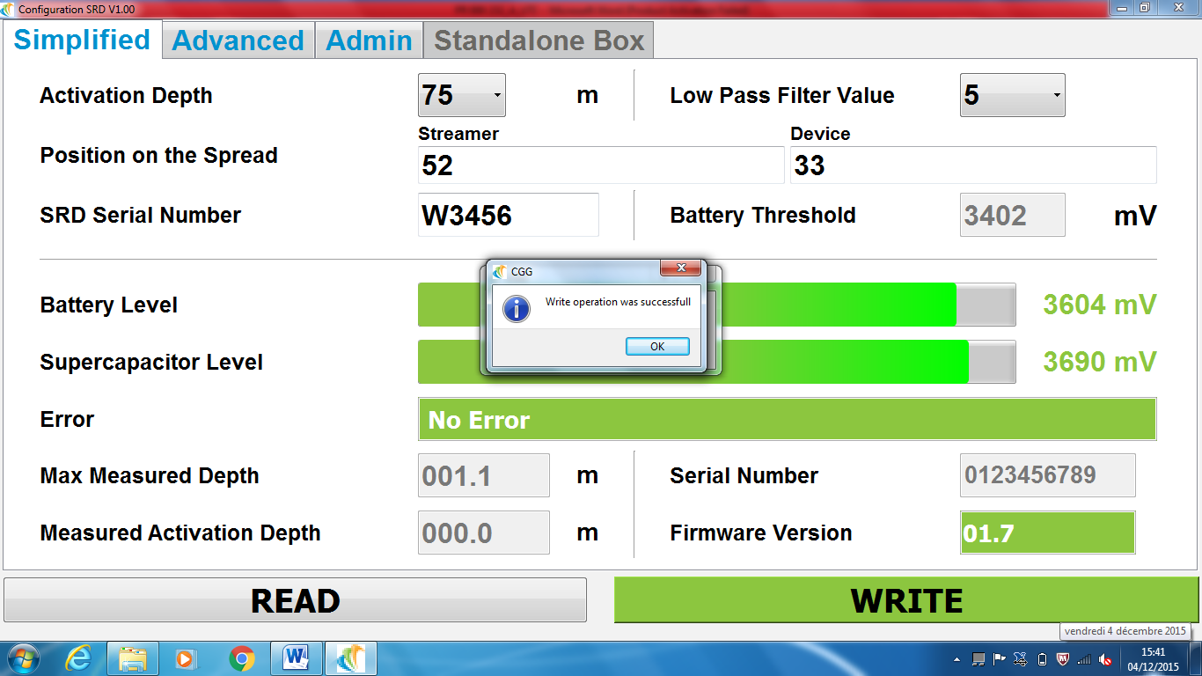

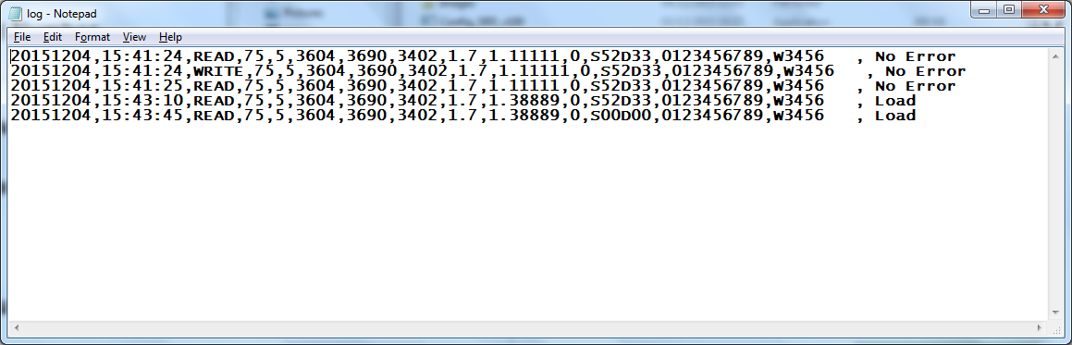

Note: The position on the Spread (Streamer and Device) cannot be set into the SRD P-Cone memory. However, you can set and save this information in the LOG File thanks to the HMI.

Trouble shooting

Truncated word
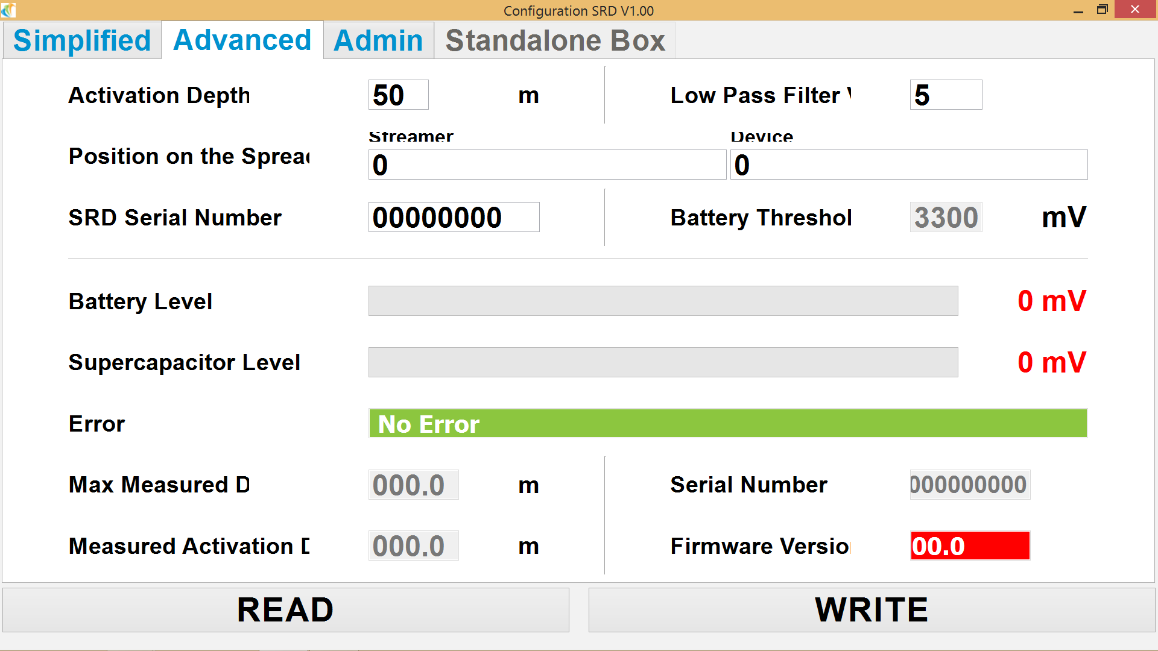

If you observe truncated word, it might be a problem of display parameters, especially on tablet. In this case, open the control panel / Display / screen resolution then select Make text and other items larger or smaller

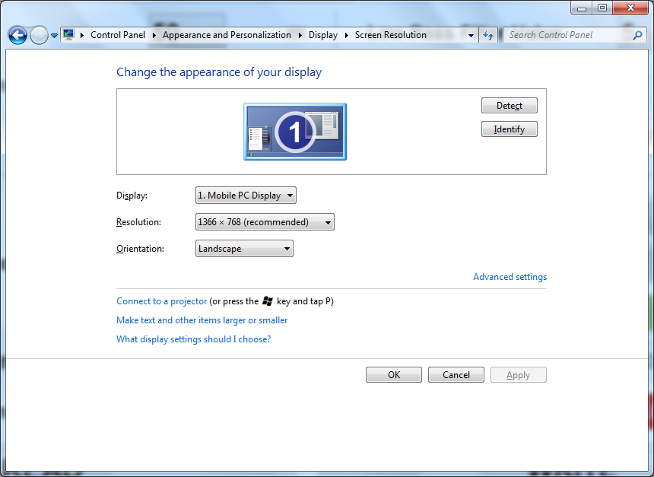

And select « smaller – 100% » and apply

