Technical Specification
Ref: MAR INS SPX 002E Version number: 1.2

Release date: 02-Dec-2013
Targeted sites: All vessels Targeted departments: TSG / ALL
Distribution list: CGG Ins., PROLANN

BROADSEIS SRD, HCI Software/Hardware

References: HCI = Human Control Interface

Document History

Version | Date | Written/Modified by | Checked by | Approved by | Comments
1.0 | 25-Nov-2013 | P. LE ROUX |  |  | Document formatted to match CGG Marine INS doc
1.1 | 27-Nov-2013 | P. LE ROUX | D. PONCEAU |  | Add, new battery values, USB antennas, and stand-alone Programming device
1.2 | 02-Dec-2013 | D. PONCEAU | P. LE ROUX | E. HAGET | Released version

Summary

Human Control Interface is a system to configure BroadSeis SRD easily. It has been designed as a tablet with integrated RFID reader and its software suited with BroadSeis SRD specifications.
First tests have shown that hardware and software improvements would be very helpful for field operation. This document describes these required improvements.
A “standalone programming device” has been imagined to simplify SRD configuration onboard a seismic vessel. Specifications for this device are defined in last chapter of this document.

Table of Content

1 Document History 1
2 Summary 1
3 Table of Content 2
4 TABLET, HARDWARE & HCI SOFTWARE IMPROVEMENT 4
4.1 Hardware 4
4.1.1 Operating system 4
4.1.2 RFID Antenna 4
4.2 Graphical software Improvement 4
4.2.1 Software compatibility 4
4.2.2 Tabs 4
4.2.3 Labels, warning levels, variable names 4
4.2.4 Battery pack levels 5
4.2.5 Permanent keyboards and buttons 5
5 TABLET SOFTWARE DEVELOPMENT 6
5.1 Hardware 6
5.2 Development environment 6
5.3 Details on data processing 6
6 USER INTERFACE DESCRIPTION 7
6.1 “Simplified” tab 7
6.1.1 “Activation depth” field 7
6.1.2 “Filter” field 8
6.1.3 “Battery level” field 8
6.1.4 “Supercapacitor level” field 8
6.1.5 “Firmware version” field 8
6.1.6 “Measured depth” field 8
6.1.7 “SRD Position” fields 9
6.1.8 “Serial number” field 9
6.1.9 “READ” control 9
6.1.10 “WRITE” control 10
6.2 “Advanced” tab 11
6.2.1 “Activation depth” field 11
6.2.2 “Filter” field 11
6.2.3 “Battery level” field 12
6.2.4 “Supercapacitor level” field 12
6.2.5 “Firmware version” field 12
6.2.6 “Measured depth” field 12
6.2.7 “SRD Position” fields 13
6.2.8 “Serial number” field 13
6.2.9 “READ” control 13
6.2.10 “WRITE” control 14
6.3 “Admin” tab 15
6.3.1 Predefined activation depth in m : 15
6.3.2 Streamer identifier 15
6.3.3 Device identifier 15
6.3.4 “Debug” and “Control” controls 16
6.3.5 Log file destination 16
6.3.6 “READ” control 16
6.3.7 “WRITE” control 16
7 Notes on field values 17
7.1 “Activation depth” field 17
7.2 “Filter” field 17
7.3 “Battery level” and “supercapacitor level” fields 17
7.4 “Firmware version” field 17
7.5 “Last measured depth” field 17
7.6 “Serial number” field 17
8 STANDALONE PROGRAMMING DEVICE 18

TABLET, HARDWARE & HCI SOFTWARE IMPROVEMENT

Human Control Interface is a system to configure BroadSeis SRD easily. It has been designed as a tablet with integrated RFID reader and its software suited with BroadSeis SRD specifications.

Hardware
Current hardware is a tablet operating on a Windows version that soon will not be maintained any more.
RFID antenna proved not to be powerful enough for field operation. USB connectors are available on the tablet.

Operating system
To change tablet operating system to Windows 8.1

RFID Antenna
A new RFID antenna to be connected to a USB port would be designed or found with these main specifications:
- Rugged USB connector
- Would still be able to read/write at a distance of at least 5 cm from the cone antenna.
- The antenna coil would be designed to fit over the cone.

Graphical software Improvement
Current software version is based on five tabs. Due to hardware improvements, two of these tabs are now useless and others need to be modified. Furthermore, first tests of HCI hardware demonstrate the need to add permanent keyboards and buttons.

Software compatibility
To make software compatible with Windows 7 to 8.1 and with an ISO15693 USB RFID reader

Tabs
To only keep the three main tabs: “Simplified”, “Advanced”, “Admin”. “Debug” tab and “Calibration” tab will be removed from code.
To remove “Debug” and “Control” controls.

Labels, warning levels, variable names
To change variable names, labels and warning levels as specified here under:

Battery pack levels
To change the display and method of computation for battery and supercapacitor levels.

Permanent keyboards and buttons
To add a permanent keypad on “Advanced” tab.
To add a permanent alphanumeric keyboard on “Admin” tab.
To increase size of “increase and decrease” buttons/arrows: they can be arranged horizontally if needed as depicted here under:

TABLET SOFTWARE DEVELOPMENT

This document defines software specifications for a Human Configuration Interface based on GLADIUS 0820 tablet.
This SRD configuration software allows configuring, verifying and calibrating BroadSeis SRD.

Hardware
GLADIUS 0820 tablet operates on Windows XP Embedded Version 5.1. Tablet includes an embedded ISO15693 RFID reader that is used by current software version.

CGG would like the tablet and software to operate on Windows 8.1.
CGG would like the software to use an ISO15693 USB RFID reader connected to any USB port of the tablet.

Development environment
Software is developed using QT, a multi-platform development environment.
Version used for this development was Qt Creator 2.4.1.

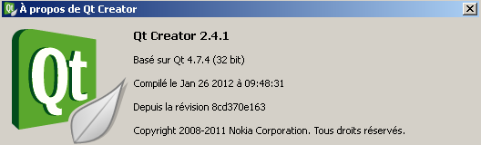

Details on data processing
Comment calculer les différentes valeurs affichées

USER INTERFACE DESCRIPTION
Default HCI tablet screen size is 800*600 pixels. This size can be user modified during operation. When tablet reboots, size comes back to its default value.
HCI doesn’t manage any right (administrator, user…).
This application doesn’t communicate through RFID at start up. Communications need to be initiated by user.

“Simplified” tab
“Simplified” tab is the tab displayed by default. It provides a minimum number of functionalities to user so that user is able to configure easily SRD.

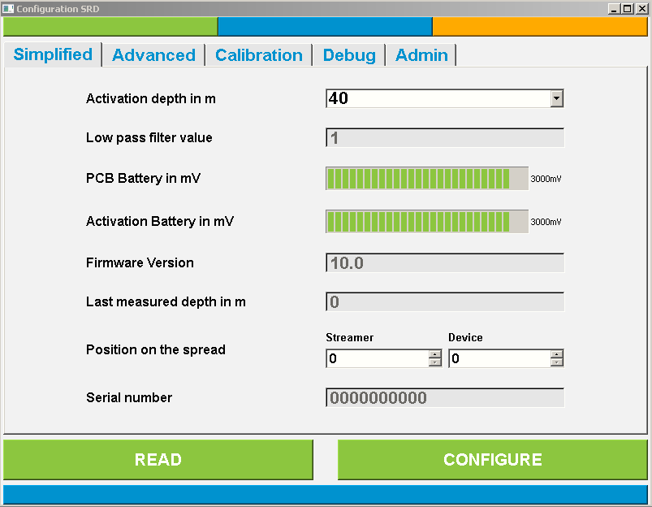

At start up, displayed values are default values. Otherwise, last values read on an SRD cone are displayed.

“Activation depth” field
This field displays SRD activation depth in meters.
Initially, user can choose between three depths which are predefined in a list under “Admin” tab. If result from a read operation is not from this list, result is temporarily added to this list.
If in “Advanced” tab, user configures a depth which is not from this list; this value is temporarily added to this list. This value is then displayed in the “Activation depth” field of “Simplified” tab.
Default value is the first one from the pre-defined list of values. Default display color is black. Default display background is white.
Display color is green when level is within a nominal range limited by two warning levels called “Warning_ActivationDepth_Min” and “Warning_ActivationDepth_Max” which are defined to 25 m and to 150 m.
Label for this field will be stored in a constant string named “ActivationDepth_Label”.

“Filter” field
This field displays SRD activation filter value. It’s the required number of successive depth measurement larger than activation depth to activate flotation bag.
This field is read-only.
Default value is called “Default_Filter” and is 5. Default display color is dark grey. Default display background is light grey.
Label for this field will be stored in a constant string named “Filter_Label”.
Display color is green when level is within a nominal range limited by two warning levels called “Warning_Filter_Min” and “Warning_Filter_Max” which are defined to 4 and to 10. Display color is red when level is without this range.

“Battery level” field
This field displays battery voltage level in mV as a 4 digit integer.
Default value is called “Default_Battery” and is 0000 mV. Default display color is red.
Display color is green when level is within a nominal range limited by two warning levels called “Warning_Battery_Min” and “Warning_Battery_Max” which are defined to 3550 mV and to 3700 mV.
This field is read-only. Display color is red when level is without this range.
Label for this field will be changed to « Battery level in mV » and stored in a constant string named “Battery_Label”.

“Supercapacitor level” field
This field displays supercapacitor voltage level in mV as a 4 digit integer.
Default value is called “Default_SuperCapa” and is 0000 mV. Default display color is red.
Display color is green when level is within a nominal range compared to battery level limited by two warning levels called “Warning_SuperCapa_Min” and “Warning_SuperCapa_Max” which are defined to 0 mV and to 25 mV. Display color is red when level is without this range.
This field is read-only.
Label for this field will be changed to “Supercapacitor level in mV” and stored in a constant string named “SuperCapa_Label”.

“Firmware version” field
This field displays firmware version as a 3 digit number with one digit after decimal separator.
Default value is called “Default_Version” and is 00.0. Default display color is red.
Display color is green when level is within a nominal range limited by two warning levels called “Warning_Version_Min” and “Warning_Version_Max” which are defined to 01.5 and to 02.0. Display color is red when level is without this range.
This field is read-only.
Label for this field will be stored in a constant string named “Version_Label”.

“Measured depth” field
This field displays last depth measured by the SRD in meter as a 4 digit number with one digit after decimal separator.
Default value is called “Default_MeasuredDepth” and is 000.0 m. Default display color is red.
Display color is green when level is within a nominal range limited by two warning levels called “Warning_MeasuredDepth_Min” and “Warning_MeasuredDepth_Max” which are defined to -005.0 m and to +005.0 m. Display color is red when level is without this range.
In current software version, this display is not always active. It will be changed.
This field is read-only.
Label for this field will be stored in a constant string named “MeasuredDepth_Label”.

“SRD Position” fields
These fields display SRD position on the spread ie on which streamer it is deployed and at which location on this streamer.
Label for these fields will be stored in a constant string named “Position_Label”.

“Streamer” field
This field displays streamer number. It’s an integer from 00 to 99.
Default value is called “Default_Streamer” and is 00. Default display color is black.
Label for this field will be stored in a constant string named “Streamer_Label”.

“Device” field
This field displays SRD location on this streamer. It’s an integer from 0 to 99.
Default value is called “Default_Device” and is 00. Default display color is black.
Label for this field will be stored in a constant string named “Device_Label”.

“Serial number” field
This field displays SRD cone’s serial number. It’s a 10 character digital field.
This field is read-only.
Default value is called “Default_SN” and is 0000000000. Default display color is dark grey. Default display background is light grey.
Label for this field will be stored in a constant string named “SN_Label”.

“READ” control
This control initiates the reading of the SRD memory.
It results in an update of these displays with the values read in the memory:
- Activation depth
- Filter value
- Battery level
- Supercapacitor level
- Firmware version
- Measured depth
- Serial Number

It also results in appending the log file with the following items:
- Date (YYYYMMDD)
- Time(HH:MM:SS)
- Action type: “READ”
- Activation depth in m
- Filter value
- Battery voltage in mV
- Supercapacitor voltage in mV
- Firmware version
- Last measured depth in m
- Position on the spread (S00D00)
- Serial Number

If an error occurs during read operation, no field is updated, log file is not appended and a pop up window indicates it to the user.

Default background color is grey. Default text color is black.
Background color toggles to grey if user acts on “READ” control or on “WRITE” control.
Background color toggles to green if process succeeds, to red if process fails.
Label for this field will be stored in a constant string named “READ_Label” and is “READ”.

“WRITE” control
This control initiates the configuration of the SRD memory which consists in three steps:
- SRD memory is read, and its content is transferred to log file (as described in previous chapter).
- Activation depth is written into SRD memory.
- SRD memory is read, and its content is transferred to log file (as described in previous chapter but with Action type changed to “WRITE”).

It results in an update of these displays with the values read in the memory:

Default background color is grey. Default text color is black.
Background color toggles to grey if user acts on “READ” control or on “WRITE” control.
Background color toggles to green if read operation is a success.
Label for this field will be stored in a constant string named “WRITE_Label” and is “WRITE” instead of “CONFIGURE” in current software version.

“Advanced” tab
“Advanced” tab provides more functionality to user so that user is able to do some special configuration easily.
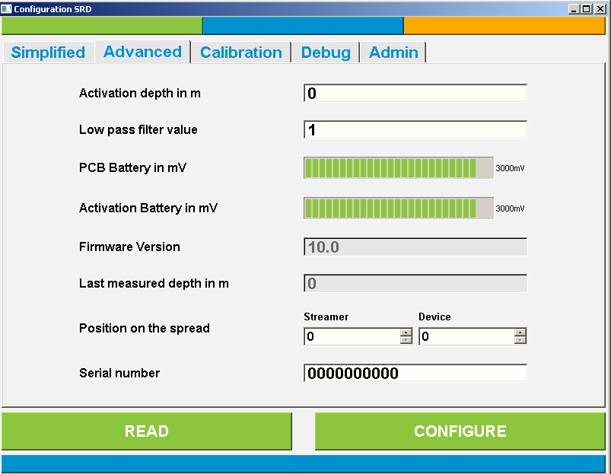

At start up, displayed values are default values. Otherwise, last values read on an SRD cone are displayed.

“Activation depth” field
This field displays SRD activation depth in meters. This field is priority over the one from “Simplifed” tab. User can input an integer in this field.
When configuring a SRD, this value is added to the pre-defined list of activation depths. To remove this value from this list, user needs to configure a SRD from this “Advanced” tab to an activation depth from the predefined list.

Default value is the first one from the pre-defined list of values. Default display color is black. Default display background is white.
Display color is green when level is within a nominal range limited by two warning levels called “Warning_ActivationDepth_Min” and “Warning_ActivationDepth_Max” which are defined to 25 m and to 150 m. Display color is red when level is without this range.
Label for this field will be stored in a constant string named “ActivationDepth_Label”.

“Filter” field
This field displays SRD activation filter value. It’s the required number of successive depth measurement larger than activation depth to activate flotation bag.
User can input an integer in this field.

Default value is called “Default_Filter” and is 5. Default display color is green. Default display background is white.
Label for this field will be stored in a constant string named “Filter_Label”.
Display color is green when level is within a nominal range limited by two warning levels called “Warning_Filter_Min” and “Warning_Filter_Max” which are defined to 4 and to 10. Display color is red when level is without this range.

“Battery level” field
This field displays battery voltage level in mV as a 4 digit integer.
Default value is called “Default_Battery” and is 0000 mV. Default display color is red.
Display color is green when level is within a nominal range limited by two warning levels called “Warning_Battery_Min” and “Warning_Battery_Max” which are defined to 3550 mV and to 3700 mV.
This field is read-only. Display color is red when level is without this range.
Label for this field will be changed to « Battery level in mV » and stored in a constant string named “Battery_Label”.

“Supercapacitor level” field
This field displays supercapacitor voltage level in mV as a 4 digit integer.
Default value is called “Default_SuperCapa” and is 0000 mV. Default display color is red.
Display color is green when level is within a nominal range compared to battery level limited by two warning levels called “Warning_SuperCapa_Min” and “Warning_SuperCapa_Max” which are defined to 0 mV and to 25 mV. Display color is red when level is without this range.
This field is read-only.
Label for this field will be changed to “Supercapacitor level in mV” and stored in a constant string named “SuperCapa_Label”.

“Firmware version” field
This field displays firmware version as a 3 digit number with one digit after decimal separator.
Default value is called “Default_Version” and is 00.0. Default display color is red.
Display color is green when level is within a nominal range limited by two warning levels called “Warning_Version_Min” and “Warning_Version_Max” which are defined to 01.5 and to 02.0. Display color is red when level is without this range.
This field is read-only.
Label for this field will be stored in a constant string named “Version_Label”.

“Measured depth” field
This field displays last depth measured by the SRD in meters as a 4 digit number with one digit after decimal separator.
Default value is called “Default_MeasuredDepth” and is 000.0 m. Default display color is red.
Display color is green when level is within a nominal range limited by two warning levels called “Warning_MeasuredDepth_Min” and “Warning_MeasuredDepth_Max” which are defined to -005.0 m and to +005.0 m. Display color is red when level is without this range.
In current software version, this display is not always active. It will be changed.
This field is read-only.
Label for this field will be stored in a constant string named “MeasuredDepth_Label”.

“SRD Position” fields
These fields display SRD position on the spread ie on which streamer it is deployed and at which location on this streamer.
Label for these fields will be stored in a constant string named “Position_Label”.

“Streamer” field
This field displays streamer number. It’s an integer from 00 to 99.
Default value is called “Default_Streamer” and is 00. Default display color is black.
Label for this field will be stored in a constant string named “Streamer_Label”.

“Device” field
This field displays SRD location on this streamer. It’s an integer from 0 to 99.
Default value is called “Default_Device” and is 00. Default display color is black.
Label for this field will be stored in a constant string named “Device_Label”.

“Serial number” field
This field displays SRD cone’s serial number. It’s a 10 character digital field.
User can input a 10 digits integer in this field.
Default value is called “Default_SN” and is 0000000000. Default display color is black. Default display background is white.
Label for this field will be stored in a constant string named “SN_Label”.

“READ” control
This control initiates the reading of the SRD memory.
It results in an update of these displays with the values read in the memory:
- Activation depth
- Filter value
- Battery level
- Supercapacitor level
- Firmware version
- Measured depth
- Serial Number

It also results in appending the log file with the following items:
- Date (YYYYMMDD)
- Time(HH:MM:SS)
- Action type: “READ”
- Activation depth in m
- Filter value
- Battery voltage in mV
- Supercapacitor voltage in mV
- Firmware version
- Last measured depth in m
- Position on the spread (S00D00)
- Serial Number

If an error occurs during read operation, no field is updated, log file is not appended and a pop up window indicates it to the user.

Default background color is grey. Default text color is black.
Background color toggles to grey if user acts on “READ” control or on “WRITE” control.
Background color toggles to green if process succeeds, to red if process fails.
Label for this field will be stored in a constant string named “READ_Label” and is “READ”.

“WRITE” control
This control initiates the configuration of the SRD memory which consists in three steps:
- SRD memory is read, and its content is transferred to log file (as described in previous chapter).
- Activation depth, filter value and serial number is written into SRD memory.
- SRD memory is read, and its content is transferred to log file (as described in previous chapter but with Action type changed to “WRITE”).

It results in an update of these displays with the values read in the memory:

Default background color is grey. Default text color is black.
Background color toggles to grey if user acts on “READ” control or on “WRITE” control.
Background color toggles to green if read operation is a success.
Label for this field will be stored in a constant string named “WRITE_Label” and is “WRITE” instead of “CONFIGURE” in current software version.

“Admin” tab
This tab allows HCI administrator to configure the predefined list of activation depths available to HCI user, and also to configure data logging.

When “Admin” tab is displayed for the first time, field values (the predefined list of activation depths, the streamer and device identifiers, and log file’s path) are default values.
Field values are saved in computer’s registry when administrator pushes “WRITE” control from this “Admin” tab. Then, field values are loaded from this registry.

Predefined activation depth in m :
These fields display the three activation depths that can be selected by the user in “Simplified” tab.
User can input integers in these fields.

Default values are called “Default_ActivationDepth_x”, where x equals 1 to 3, and are 50, 75 and 100 m. Default display color is black. Default display background is white.
Display color is green when value is within a nominal range limited by two warning levels called “Warning_ActivationDepth_Min” and “Warning_ActivationDepth_Max” which are defined to 25 m and to 150 m. Display color is red when level is without this range.
Label for this field will be stored in a constant string named “PredefinedActivationDepth_Label”.

Streamer identifier
This field displays the character used in the log file as streamer identifier.
Default value is called “Default_StreamerIdentifier” and is ‘S’. Default display color is black. Default display background is white.
Label for this field will be stored in a constant string named “StreamerIdentifier_Label”.

Device identifier
This field displays the character used in the log file as streamer identifier.
Default value is called “Default_DeviceIdentifier” and is ‘D’. Default display color is black. Default display background is white.
Label for this field will be stored in a constant string named “DeviceIdentifier_Label”.

“Debug” and “Control” controls
These controls have to be removed.

Log file destination
This field displays log file’s path.
Default value is called “Default_LogFilePath” and is “C:\log.txt”. Default display color is black. Default display background is white.
Label for this field is stored in a constant string named “LogFile_Label” and is “Log file destination”.

Log file is a text file where are saved all communications with SRD: read, configure or calibrate. Each action is separated by a line break
Each line begin with the date (YYYYMMDD), the time (HH:MM:SS) and the action type (READ, WRITE and CALIBRATE). Read parameters are then separated by comma.

Example:
…
20131128, 17:26:01, READ, 050, 3650, 3640, 01.5, -000.2, S01D35, 2013012345
20131128, 17:26:21, READ, 050, 3651, 3642, 01.5, -000.5, S01D34, 2013012346
…

“READ” control
This control has to be removed.

“WRITE” control
This control writes into tablet/computer register the three pre-defined activation depths.

Notes on field values
This chapter describes how to compute values to put in the fields defined here before from the values read in the RFID memory.

“Activation depth” field
Activation depth is stored in byte 5 of RFID memory. A change of this byte induces a change in general checksum stored in bytes 18 and 19 of RFID memory.

“Filter” field
Filter value is stored in bytes 6 (MSB) and 7 (LSB) of RFID memory. A change of these bytes induces a change in general checksum stored in bytes 18 and 19 of RFID memory.

“Battery level” and “supercapacitor level” fields
Battery level and supercapacitor level are stored in bytes 32 and 33 of RFID memory. These bytes must not be modified by HCI.
From firmware version 2.0, these levels are stored in RFID memory differently than for previous versions. Battery and supercapacitor level measurements are stored on one byte normalized to the maximum value they can reach: 3700 mV or 604 LSB.

Measurement | Stored value
0 to 349 LSB | 0 LSB
X from 349 to 604 LSB | X-349 LSB
605 to 1023 LSB | 255 LSB

Furthermore, gain from measured level in LSB to voltage is 0.16337 LSB/mV.

“Firmware version” field
Firmware version is stored in byte 0 of RFID memory. This byte must not be modified by HCI.
Stored value is the hexadecimal number corresponding to firmware version multiplied by 10.

Firmware version | Stored value
01.5 | 0x0F
01.7 | 0x11
02.0 | 0x14

“Last measured depth” field
Activation depth is stored in bytes 40 (MSB) and 41 (LSB) of RFID memory. These bytes must not be modified by HCI.
Stored value is raw measurement. Measured depth can be computed with this formula:
Depth = (Stored value-Offset)/Gain
Offset=60 LSB; Gain=3.60 LSB/m

“Serial number” field
Serial number is stored in bytes 20 to 29 of RFID memory. A change of these bytes induces a change in general checksum stored in bytes 18 and 19 of RFID memory.

STANDALONE PROGRAMMING DEVICE

CGG would like to develop a "standalone programming device" that would be used to verify configuration of a batch of SRD or to program this batch of SRD with a same configuration.

This standalone programming device consists in a main box and a cable antenna specified as defined here under:
- Main box is equipped with two controls that are used to trigger read/write SRD cone
- Main box stores data content exchanged with SRD cones (read and written) in a memory
- Main box’s memory is large enough to store a thousand of data exchanges.
- Main box’s memory can be read and write by a tablet or computer via a USB cable.
- Main box is equipped with a two color LED display visible through a light guide
- Main box’s LED display blinks after data verification:
  - LED display blinks green after data exchange if data verification is a success
  - LED display blinks red otherwise
- Main box is watertight and equipped with a unique watertight connector (IP68)

- Cable antenna is equipped with an RFID antenna
- Cable antenna fits SRD's front shape so that the RFID antenna is well located (5 cm) in front of SRD’s antenna
- Cable antenna is watertight and terminated with a watertight connector (IP68)
- Cable antenna is small enough not to interfere mechanically with SRD neighborhood (collars, other SRDs...)
- Cable antenna is directive enough not to interfere with other SRD than the target (shields to be added if needed)

- Each write operation would be followed by a data verification to check write operation
- Each “standalone programming device” configuration operation by the tablet/computer would be followed by a verification of this configuration

- “Standalone programming device” is provided with a 2 m-long USB cable to connect it to the laptop/tablet.
- USB cable is terminated by the same IP68 connector than cable antenna.
- Software is provided to log data on a laptop and to clear main box’s memory.
- Software operates on Windows 7 to 8.1.
- Data logging format is the same as that of HCI where date and time are that of data download.

